

**CIS 11051 – PRACTICAL FOR DATABASE DESIGN**

Information and communication Technology

Faculty of Technology

South Eastern University of Sri Lanka

Registration Number: SEU/IS/22/ICT/075

Academic year: 22/23

LabSheet02

**Task 1**

1. Open MS Access -> click on “Blank Document” -> click on “create” -> in ribbon tab click on “external data” -> new source data -> from file -> Excel

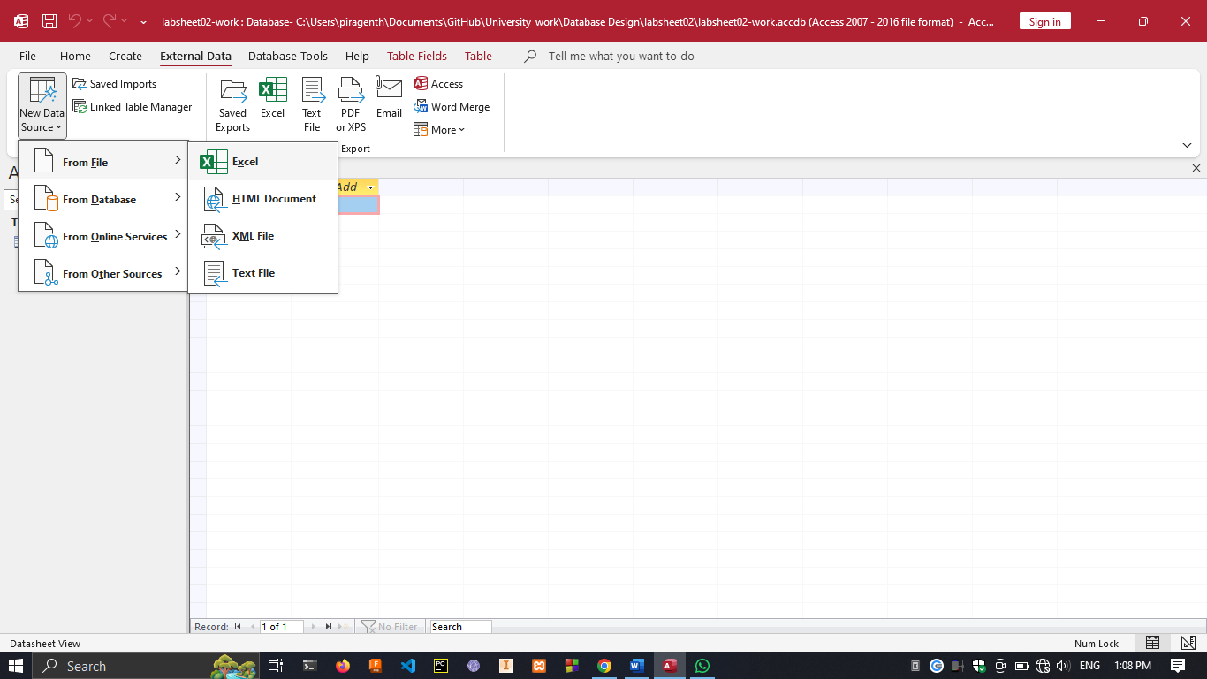

1. Select column name “First Name” -> Under “Home” -> click on “Ascending”

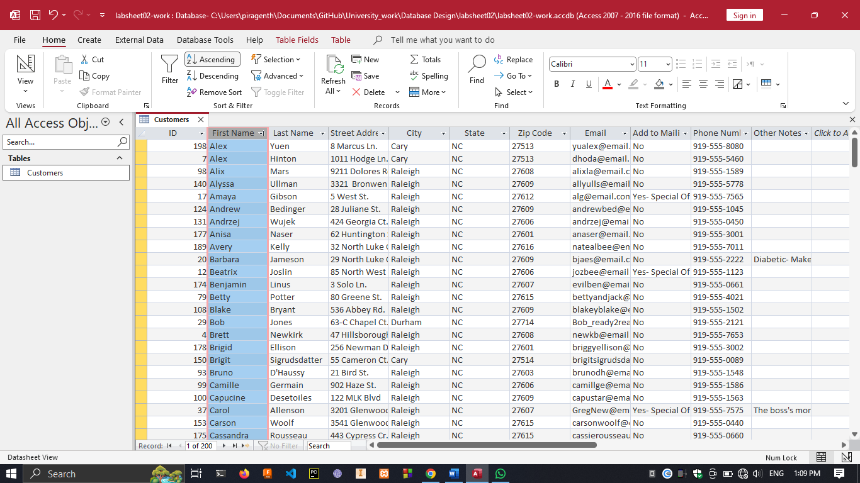

1. Select “city” -> In “home” -> select “filter” -> uncheck all boxes other than “Chapel Hill”

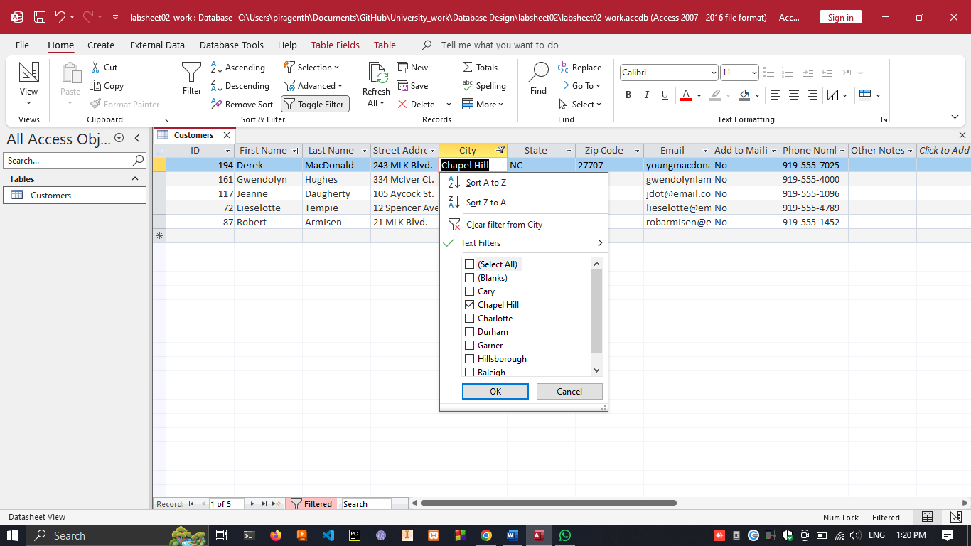



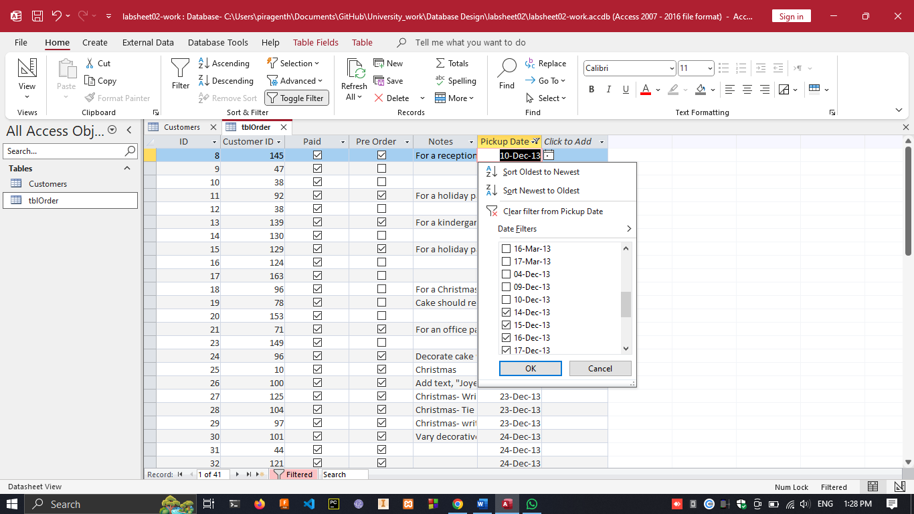

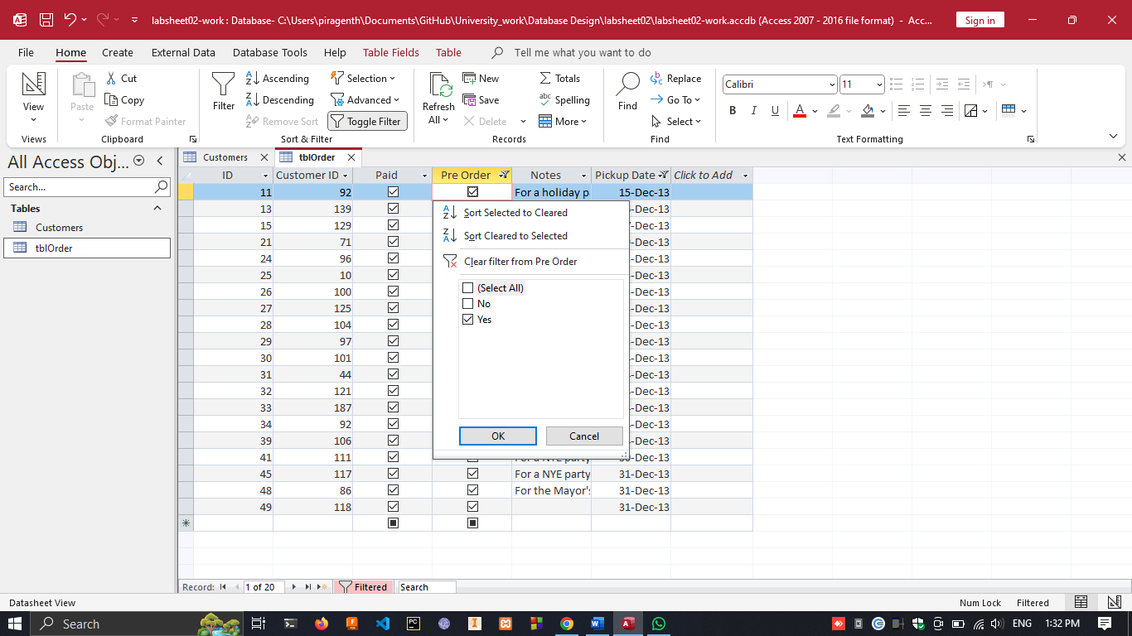

1. Form

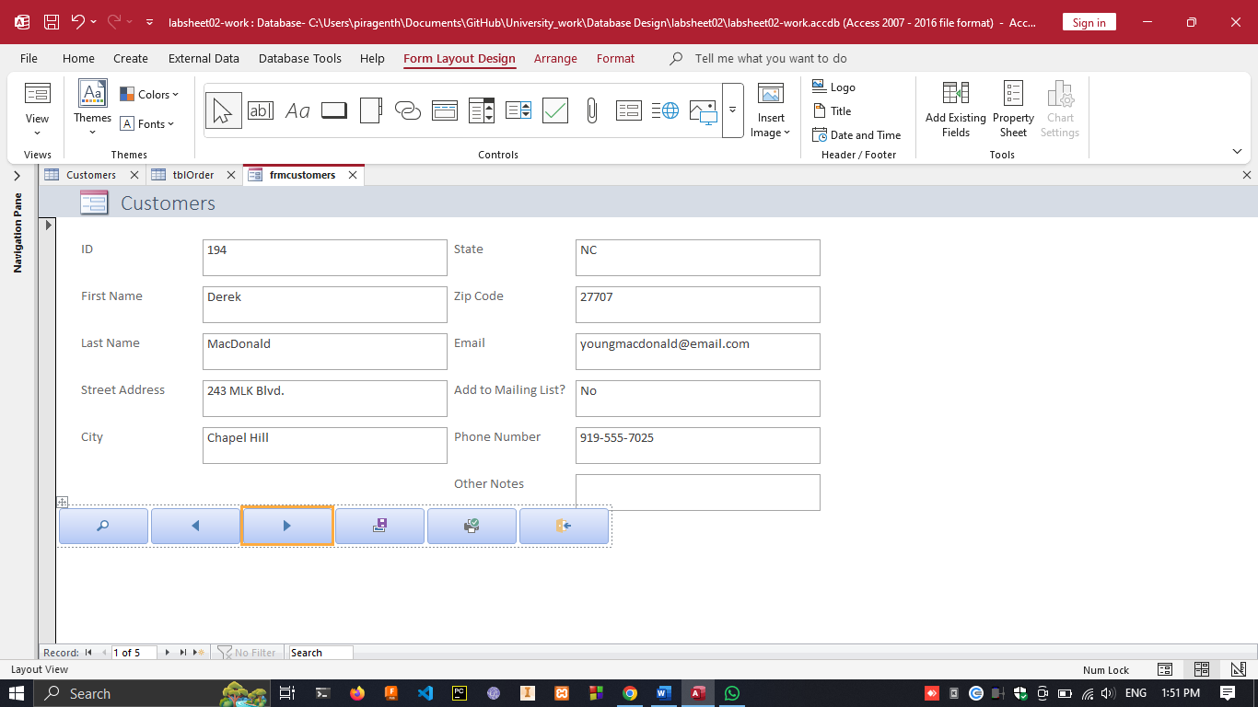

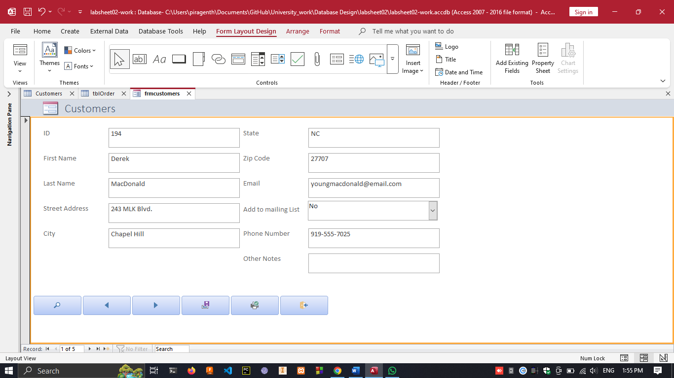

**Task02**

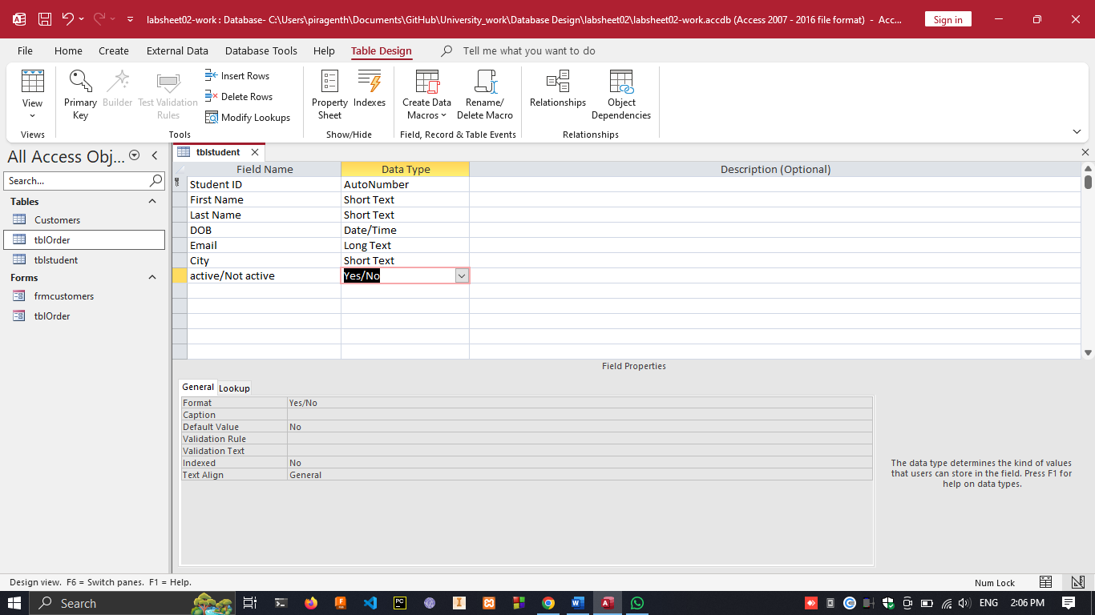

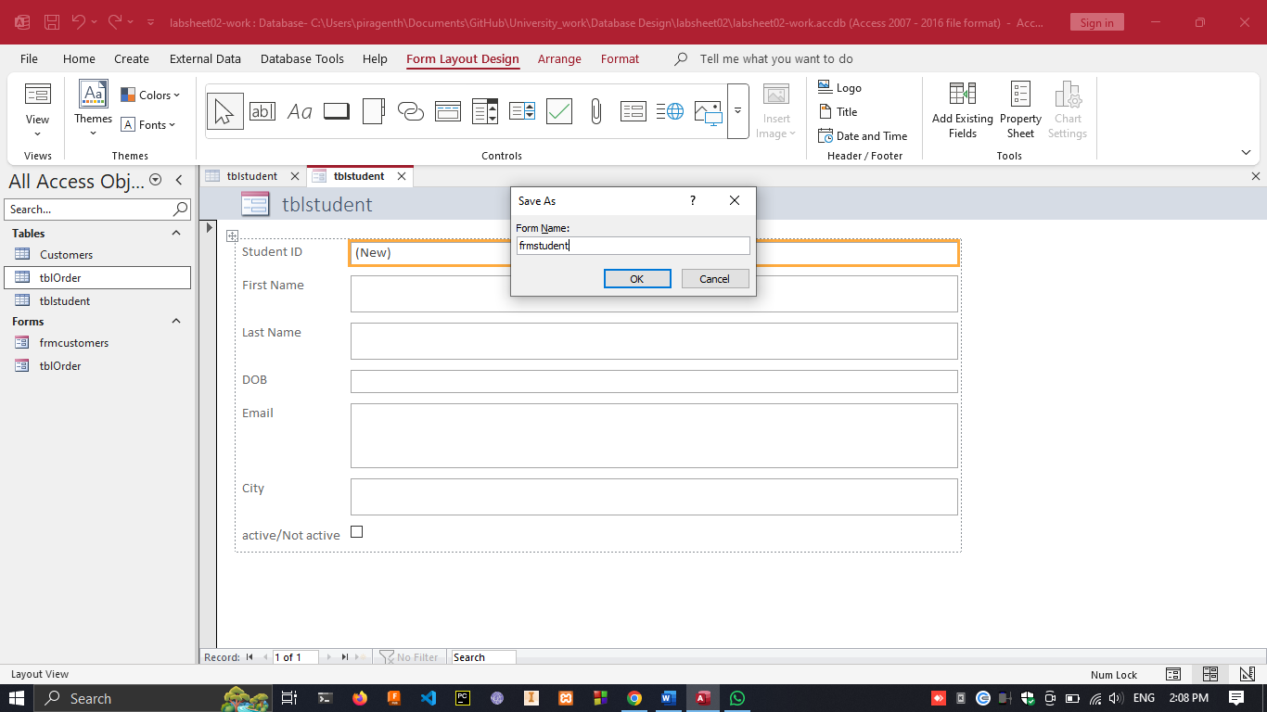

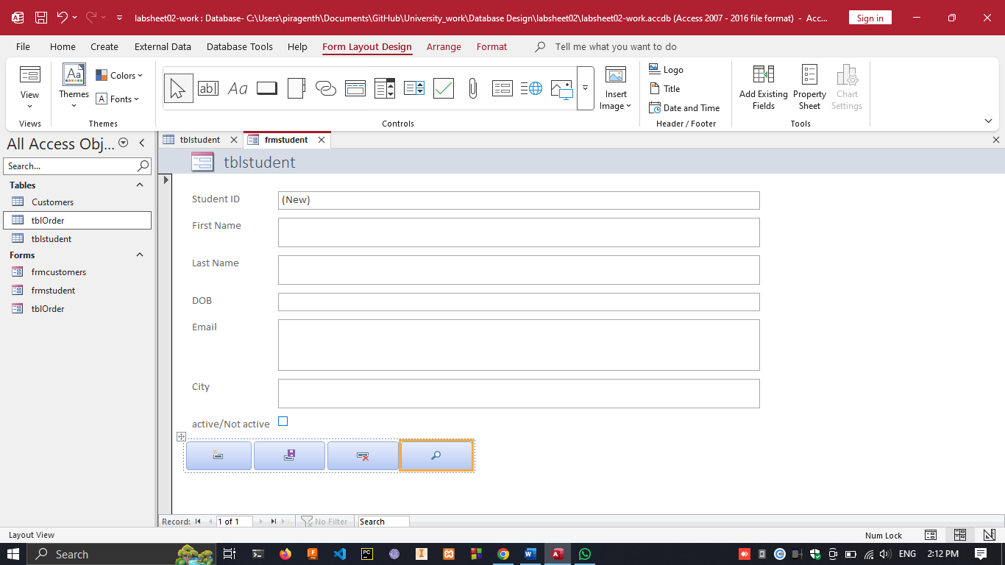



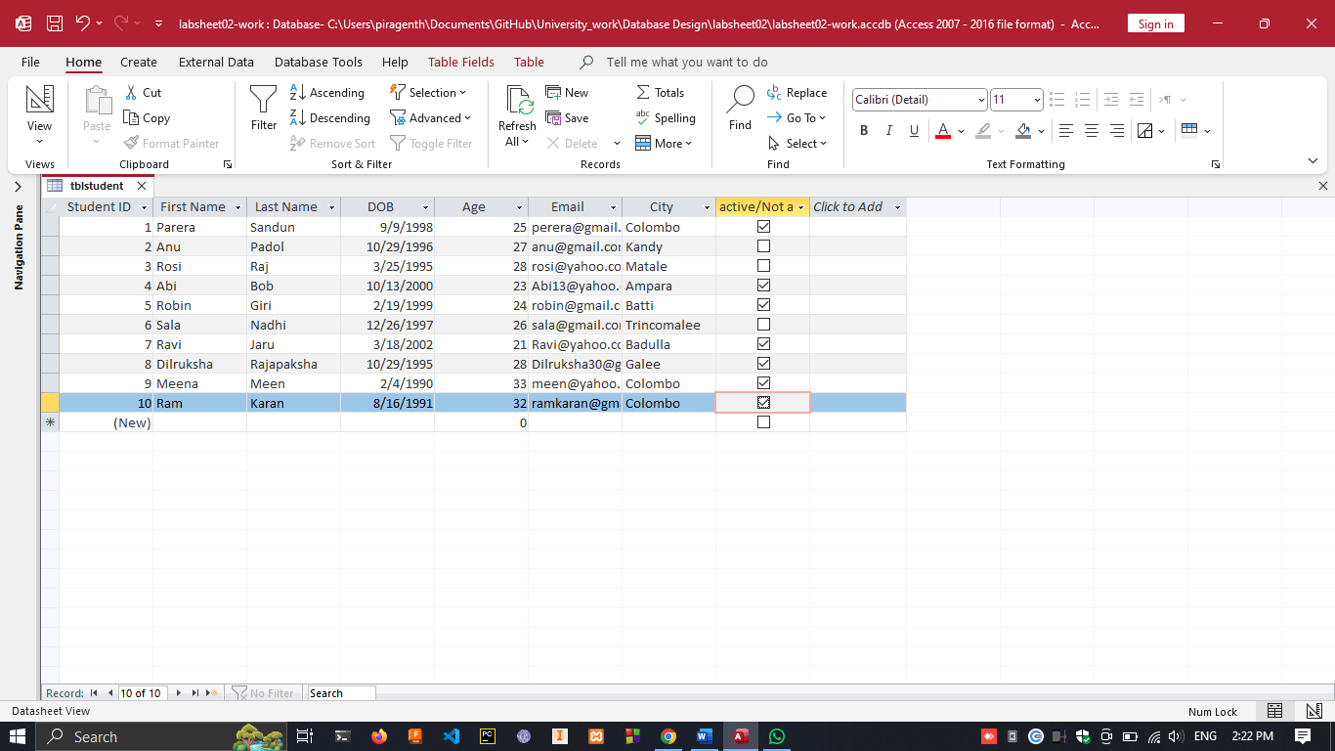



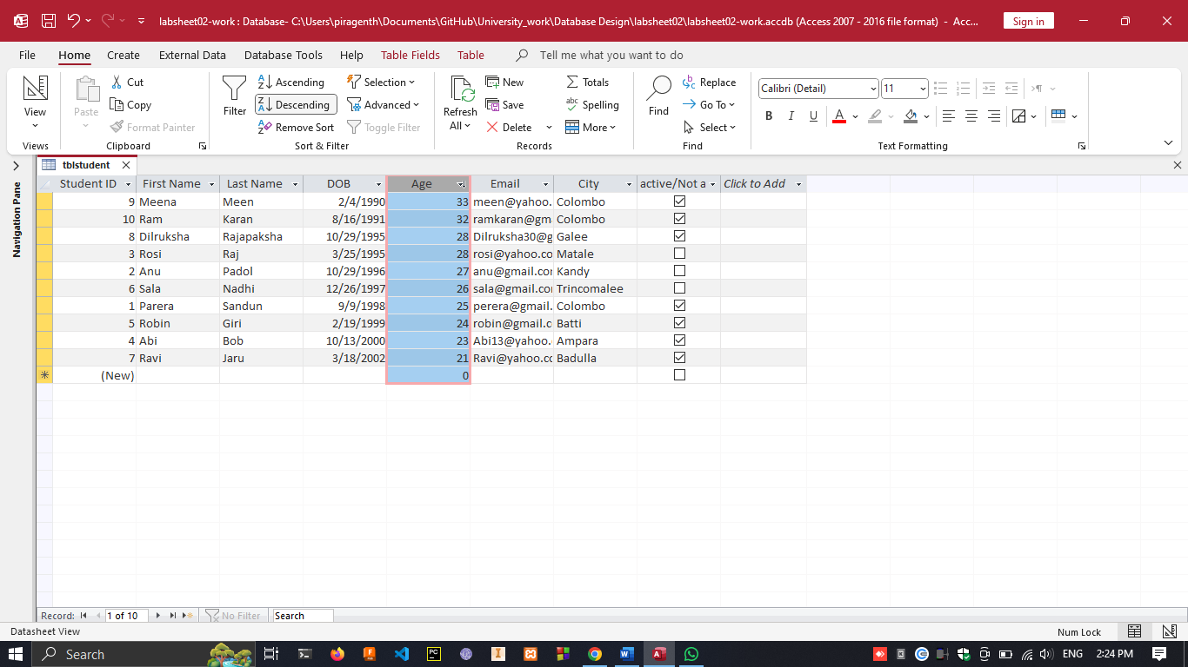

1. Click on “create” tab -> click “Query Design”

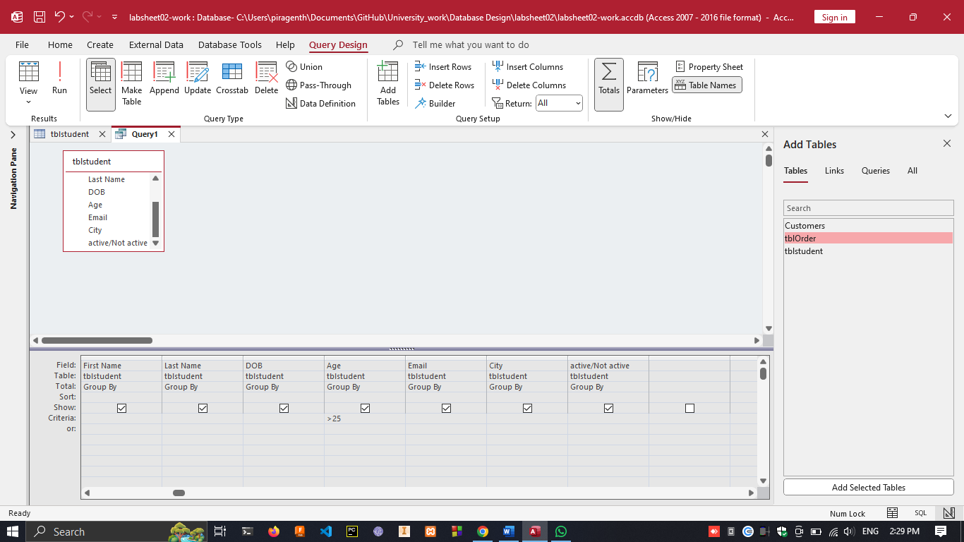

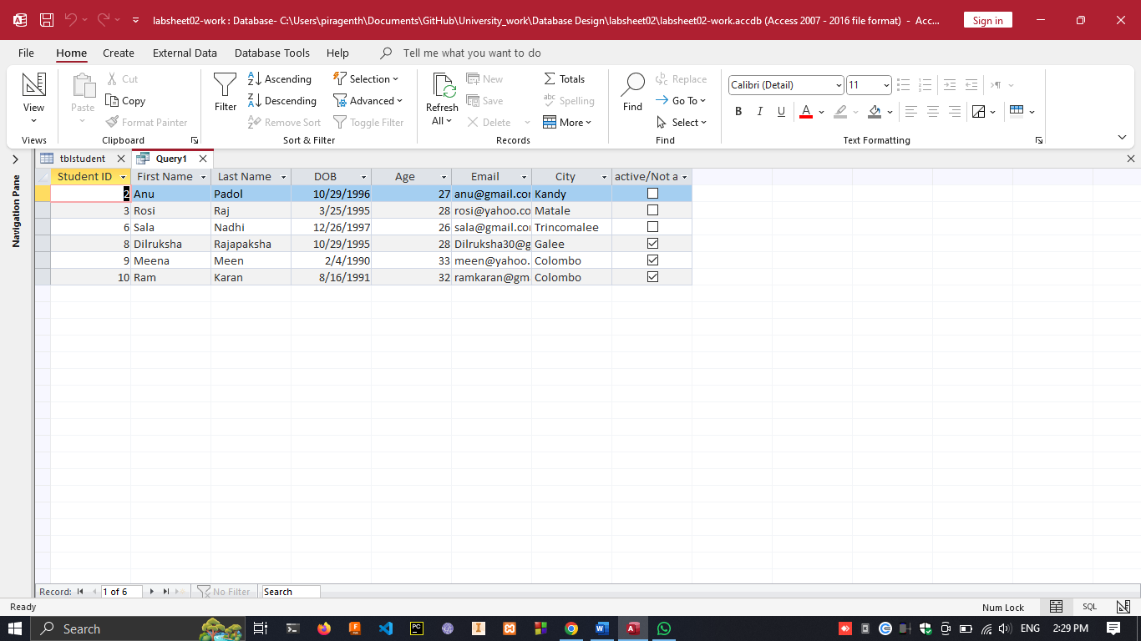

**To Add new Record**

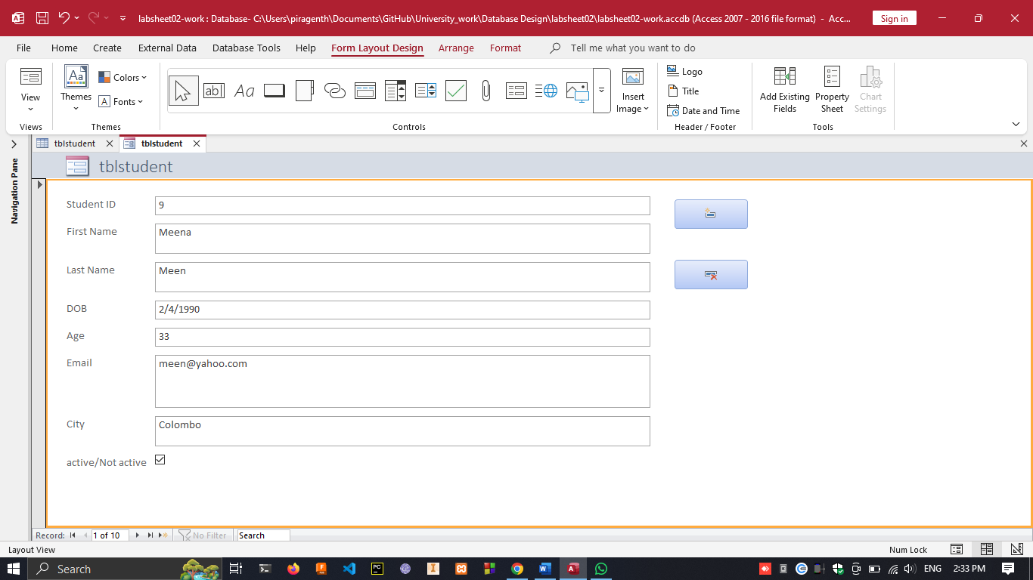

**To Delete Record**

